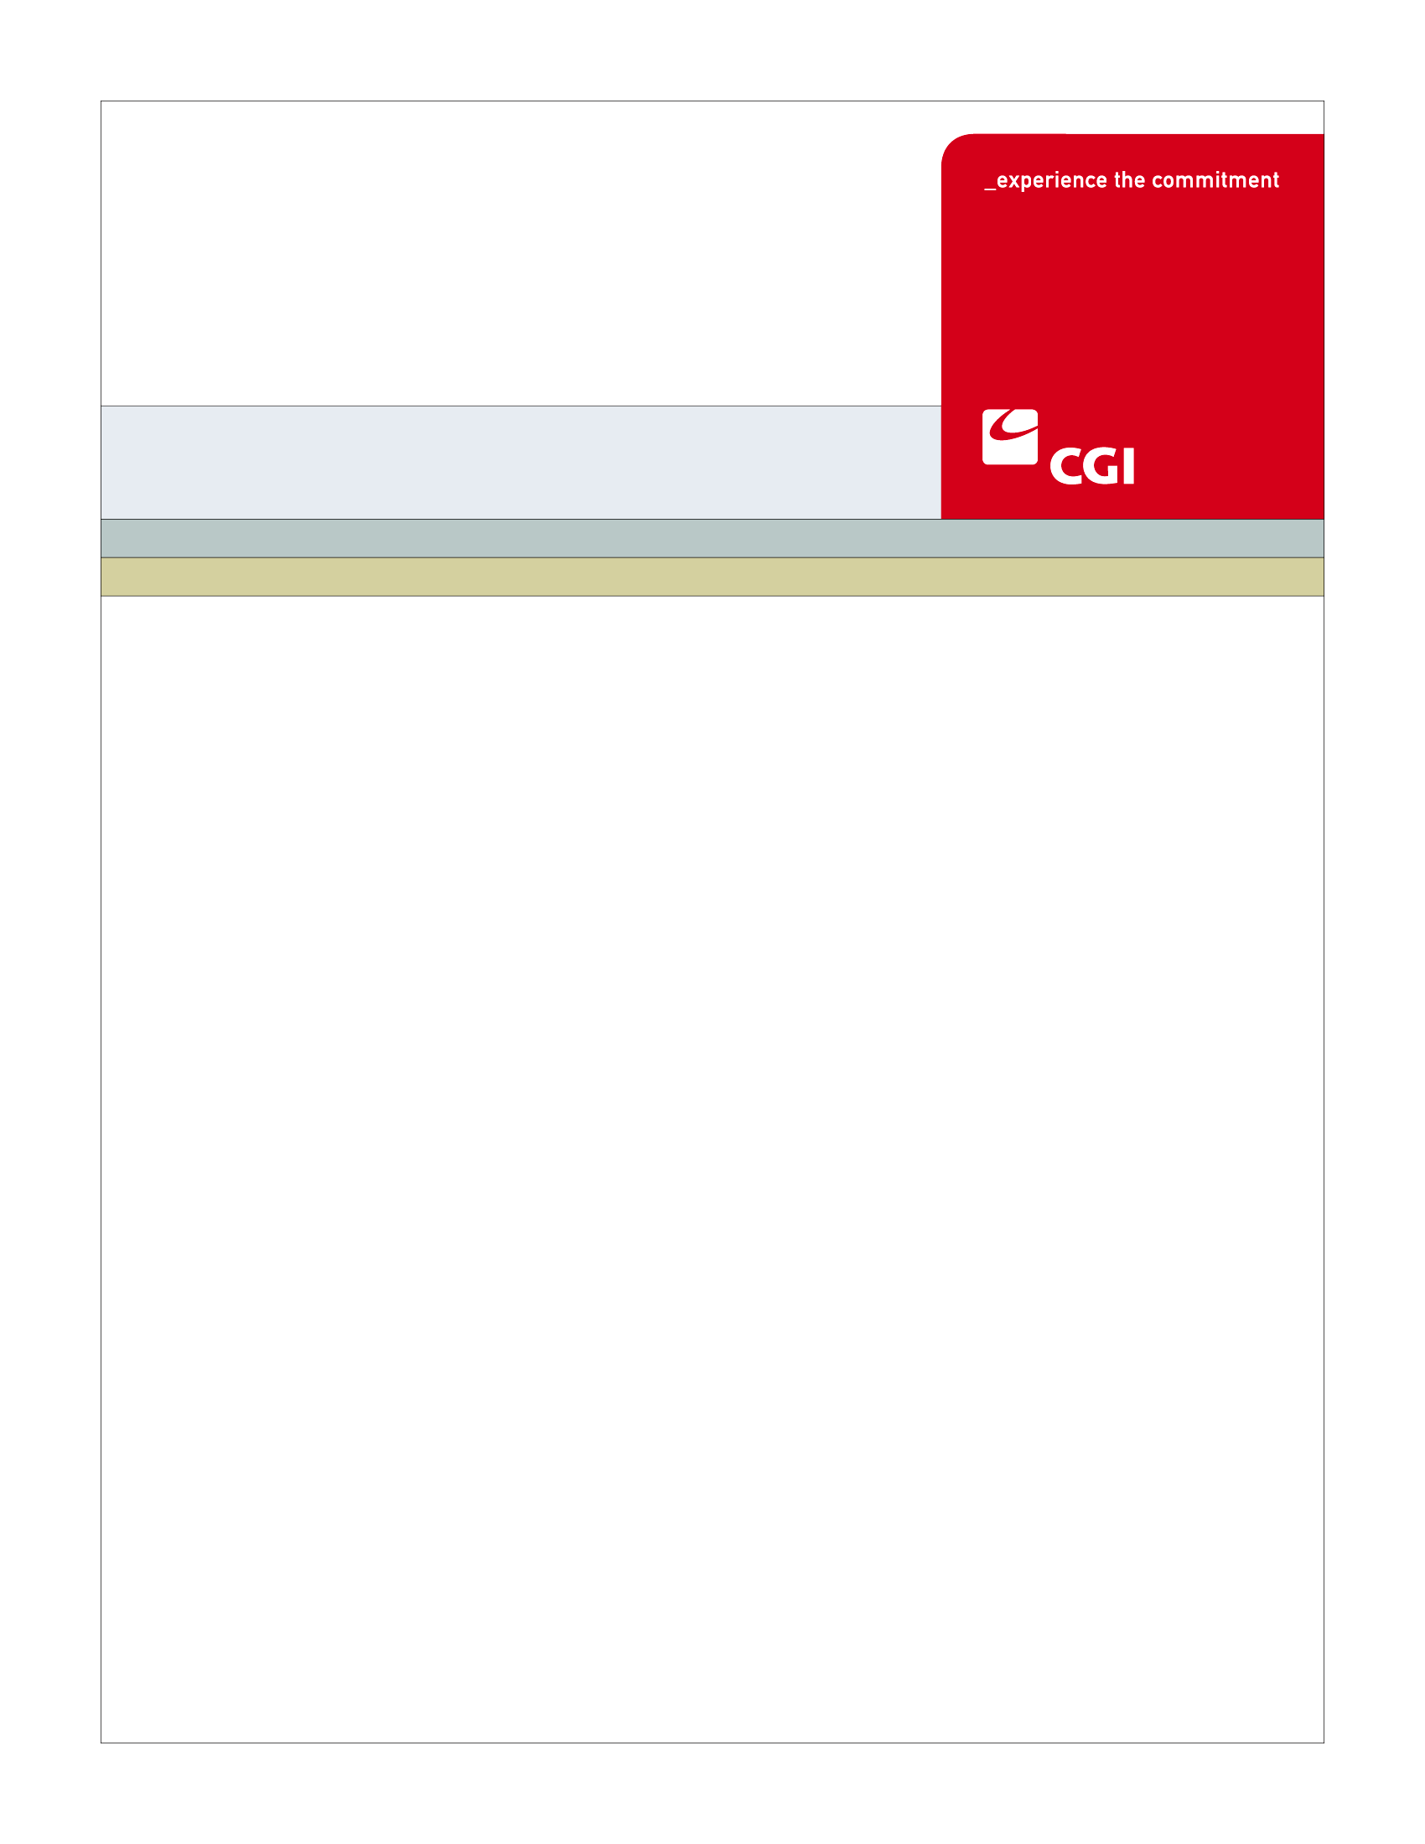

USE
Colorado Health Benefit Exchange (COHBE)
Version 2.0
October 25, 2012
PS-002
Shop for Individual Plan
Use Case
REVISION HISTORY
Version | Date | Modified By | Description
0.1 | 2012-09-11 | Pat Babcock | Initial Draft
0.2 | 2012-09-24 | Pat Babcock | Updated after JAD Discovery session
0.3 | 2012-10-01 | Pat Babcock | Updated after JAD Elaboration session
1.0 | 2012-10-16 | Pat Babcock | Updated after JAD Verification session
2.0 | 2012-10-24 | Jenny Wu | Update for comments from discussion with Adele and Jessica.

TABLE OF CONTENTS
1 Use Case: Shop for Individual Plan 5
1.1 Goal 5
1.2 Brief Description 6
1.3 Requirements Traceability 6
1.4 Primary Actor(s) 8
1.4.1 Individual 8
1.4.2 Broker 8
1.5 Secondary Actor 8
1.5.1 Exchange 8
1.6 Pre-Conditions 9
1.7 Post-Conditions 9
1.8 Triggers 9
1.9 Assumptions 9
2 Flow of Events 10
2.1 Basic (Main) Flow – Shop for Individual Plan 10
2.1.1 View Plans Relevant for Customer 10
2.1.2 Modify APTC 11
2.1.3 Sort Plans 11
2.1.4 Filter Plans 11
2.1.5 Compare Plans and Plan Details 11
2.1.6 Does User Want to Select a Plan? 11
2.1.7 Does User Want to Return to Modify APTC? 12
2.1.8 Does User Want to Keep Shopping? 12
2.1.9 Add Plans to Shopping Cart 12
2.1.10 Does Plan Have Riders? 12
2.1.11 Does User Want to Add Rider? 12
2.1.12 Add Rider to Shopping Cart 12
2.1.13 Proceed With Registration? 13
2.1.14 Next Steps 13
3 Alternate Flows 13
4 Exception Flows 13
4.1 End Shop for Individual Plan Session 13
4.1.1 End 13
5 Specifications 14
5.1 Business Rules 14
5.1.1 Determining Plan Premium 14
5.1.2 Determining Rider Cost 14
5.1.3 Catastrophic Plans 14
5.1.4 User Fees 14
5.2 Process Rules 14
5.2.1 Available Riders 14
5.3 Workflow 14
5.4 UI Screen Details 14
5.4.1 Relevant Plans 14
5.4.2 View Riders 15
5.5 Communications 15
5.5.1 Imaging Requirements 15
5.5.2 Form Requirements 16
5.5.3 Notices Requirements 16
5.5.4 Other Communication Requirements 16
5.6 Interfaces 16
5.7 Reporting 16
5.7.1 Usage Report 16
5.8 User Security 16
5.9 Activity Log and Audit Trail 17
5.9.1 Activity Log and Audit Trail 17
6 Future Release Notes 17
Appendix A - Glossary 18
Appendix B – Data Elements 21

Use Case: Shop for Individual Plan

Goal
The goal of this Use Case is to provide the Customer the ability to shop for health plans (including CSR and Catastrophic) after logging into the Individual Exchange and providing at least some Personally Identifiable Information (PII). The individual can filter, sort, and compare plans, plan details, and view costs minus exchange benefits, if applicable. The individual may Shop for a Plan before or after determining their eligibility for subsidies. If they have been deemed eligibile for APTC / CSR, the plans shown and the premiums displayed will be adjusted to reflect their benefits.

This Use Case completes succesfully when the individual shops for plans available to him/her based on the personal information they have entered. The Customer can then select a plan to be placed into a shopping cart, which is accessed once the Customer decides to enroll within the Exchange.

Brief Description
When the Individual visits the Exchange, based on information provided by the Customer, the system will display all available relevant plans including any special plans such as Catastrophic or Cost Sharing Reduction (CSR) plans.
If the Customer is eligible for the Advance Premium Tax Credit (APTC), the plan will be displayed with premium cost, less APTC amount, to the user. Additionally, if the user is shopping for a family that has mixed eligibility, the Exchange will present CHIP plans for which family members are eligible for in addition to Qualified Health Plans (QHPs).
The user can modify APTC, sort, filter, compare, review, select plans and associate riders, if applicable. If the Customer finds a plan they like, the Customer may add the plan to the shopping cart, check out and proceed to registration for enrollment.

Requirements Traceability
The following requirements are covered within this Use Case:
- EL210: The System shall calculate and display the net (actual) cost of coverage, including premium cost to reflect APTC, based on amount of APTC customer selects.
- FM17: The System shall have the ability to optionally add user fees to plan rates prior to plan shopping. Note that Small Group plans are required by law to include user fees by the carriers but carriers currently have the option to provide plan rates to the Exchange with or without user fees included.
- FM19: The Individual Exchange will provide Administrative Fee Processing (the calculation of fees due to COHBE based on the rules configured).
- GF076: Service Representatives will be able to perform all of the activities of the System on behalf of Customers, should Customers need assistance or not have access to the System. Activities of Service Representatives will be limited to the functions required by their roles.
- PM180: The System will have the ability to show complaint information by carrier during Plan Selection.
- PS010: The System shall allow consumers to view and select qualified health insurance plans with or without a subsidy, Medicaid, CHIP, dental and vision plans within their coverage area for which the individual and/or members of the household are eligible, including SHOP plans.
- PS020: The System shall display plans in a consistent format showing total premium, adjusted premium tax credit, co-pay/coinsurance, annual deductibles and other relevant information (e.g. carrier, network, rating, etc.).
- PS030: The System shall have the option to present Medical plans by metal levels of coverage (Catastrophic, Bronze, Silver, Gold or Platinum) to enable side-by-side comparison of similar plans, i.e. silver and gold from each carrier.
- PS035: The System shall have the ability to accept, display and assign customers to catastrophic plan types. Catastrophic plans are a lower level metal tier than Bronze plans. There may be specific eligibility criteria for these plans.
- PS040: The System shall present plans in a default order based on one or more of the plan attributes.
- PS041: The System shall have the ability to load, price and display plan riders (e.g., additional chiropractic visits, mental health upgrades) if Carriers and COHBE choose to offer these options on the Exchange.
- PS042: The System shall allow customers to filter, sort and compare QHPs and any associated riders. If the customer selects one or more riders along with a QHP, the price, sort and compare functions will include these additional benefits and costs.
- PS050: The System shall enable the customer to filter based on various criteria, including but not limited to:
  - net price (plan cost less subsidy or employer contribution)
  - healthcare provider
  - deductible
  - location/availability of network and out of network providers
  - rating
  - health specialty area
- PS060: The System shall enable the user to sort plans in a tabular format based on various sort criteria, including but not limited to:
  - net price (plan cost less subsidy or employer contribution)
  - deductible
  - rating
- PS062: Customers can view a geographic map of providers and hospitals associated with particular Carrier plans.
- PS070: The System shall display plans such that the user can drill down to two additional levels to more detail on any particular plan.
- PS080: The System shall include tools to filter and sort plans which shall be on the same page that plans are displayed, e.g. filter will continue to be displayed as the customer scrolls down the page.
- PS090: Customer will be able to select up to 3 plans to review in detail in a side by side comparison format. Side by side comparison will enable the Customer to identify plan attributes which have impact on their desirability such as emergency room visit costs, prescription co-pays, and costs of diagnostic services.
- PS101: If an individual is determined eligible for qualified health plans with or without a subsidy, the individual can proceed to select and complete enrollment in available health plans.
- PS103: The Exchange will include a shopping cart feature which will allow the logged in Customer to save selected health, dental and vision plans for review in future online sessions if the Customer chooses not to finish the Customer’s selection within the session. This will allow the Customer to revisit the selected plan and make any changes or additions before final selection is made and the enrollment process begins.
- PS104: All potential eligible plans may be selected through the Exchange in cases where households have mixed eligibility.
- PS105: The System shall provide the customer with the ability to select from a variety of CSR plans for which they are eligible.
- PS230: The System shall provide a listing of individual product costs, i.e. health plan and dental and vision plans individually and in aggregate which shows the total monthly price.

Primary Actor(s)

Individual
An Individual will enter the Exchange to shop for QHP plans available to them and their family members after creating an account..

Broker
A Broker will enter the Exchange to act on behalf of an Individual to shop for QHP plans that are available to their clients and family members after creating an account

Secondary Actor

Exchange
The Exchange will provide search results based on information the Customer has entered by determining the relevant plans for the Customer. The user will be able to modify APTC, sort, filter, compare, and select plans available to them on the Exchange. The plan plus rider(s) selected can be added to the shopping cart.

Pre-Conditions
Prior to entering this Use Case, the Customer may have completed Provide Household Information Use Case or Determine Individual Eligibility Use Case or Certify Plan Use Case.
Data elements from Provide Household Information Use Case to be populated prior to this Use Case include:
- Zip Code/County
- Household Composition
- Age based on Birth Date
- Smoking status

If Customer is entering use case from Determine Individual Eligibility additional data elements available would include:
- Income
- Incarceration Status
- US Citizenship

Data elements from Certify Plan Use Case to be populated prior to this Use Case include:
- Plans from Carriers

Post-Conditions
This Use Case is complete when the Customer has added a plan to the Shopping Cart to be used in the next steps within the Exchange, such as Submit Individual Application.

Triggers
The following events would trigger this Use Case:
- An Individual has created an account and provided basic information and may or may not have anonymously shopped. If Individual has anonymously shopped, their shopping cart will be available in this use case.

Assumptions
- This Use Case may be updated for Dental and Vision requirements or a separate use case will be created.
- Once Navigator’s role has been defined, this Use Case may be updated or a separate use case will be created.
- Individuals and Service Representatives will have the same capabilities in all functional flows (Service Reps will actually have more than Individuals) – therefore any reference to an Individual will apply to Service Representatives.
- CHIP plans will be displayed, unless decision changes.

Flow of Events
The Business Process Activity diagram below shows the COHBE processes for the Shop for Individual Plan Use Case. The steps numbered on the diagram below have detailed explanations in the sections that follow.

Figure 1: Shop for Individual Plan BPM
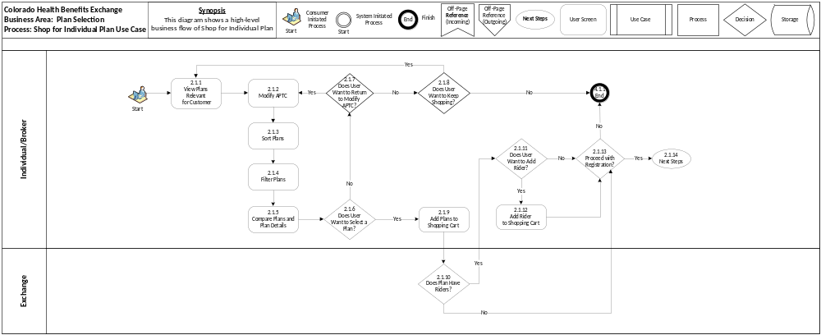

Basic (Main) Flow – Shop for Individual Plan
The Basic Flow through this Use Case is the user entering their account to shop for plans that they are eligible and to add those plans to the Shopping Cart. They will be able to modify APTC, sort, filter, compare and select a plan for themselves as well as each member of their family.

View Plans Relevant for Customer
The user will be able to view a list of plans and rates available to them, based on zip code/county, household composition, smoking status and age. From the list of relevant plans, a user will be able to Sort, Filter, and Compare Plans.
The list of plans provides the first level of detail about the plans. Users can view plan details, which would provide a second level of detail. The second level of detail is also available when comparing plans. A third level of detail will be provided by clicking on a carrier, which will show a popup screen that provides reference links to more detailed information about that carrier presented as PDFs, such as MLR, Complaints, Certification, and Quality measures. Additionally, if the user is shopping for a family that has mixed eligibility, the Exchange will present CHIP plans for which family members are eligible in addition to Qualified Health Plans (QHPs).
Plans will have User Fees (Business Rule, Section 5.1.4) built into the plan cost, if applicable.

Modify APTC
Users may modify amount of APTC from view plans to see how this will impact their monthly premium. The user may return to Modify APTC multiple times to view how it affects their premium amount or they may opt out of APTC altogether.

Sort Plans
To sort, the user selects the sort option from the dropdown box. Only one sort can be applied at a time during any shopping experience. The default sort is by Premium= Amounts from Lowest to Highest. See Appendix B, column “Sort” for the data elements that the user is able to sort on.

Filter Plans
The filters should list the number of plans that pass the filters and the total number of available plans. See Appendix B, column “Filter” for the data elements that the user is able to filter on.

Compare Plans and Plan Details
See Appendix B, column “Plan Detail or Comparison” for fields displayed during comparison.

If the user chooses to compare plans, they can compare up to 3 plans at a time, in a side-by-side comparisons for an unlimited number of times, until they find a plan that meets their needs. On the Compare/Plan Details page, the Customer will be able to view a geographic map of providers and hospitals associated with a particular Carrier’s plan.

Does User Want to Select a Plan?
The Customer selects the plan that they feel fit their needs best by clicking the “Add to Cart” button from either within the plan listings or on the comparison screen. If the user chooses not to add a plan to the Shopping Cart, they will proceed to Step 2.1.7. If no plan was added to the Shopping Cart, then the checkout button will be disabled and the user will not be able to proceed to enrollment unless a plan has been selected. If a user chooses to add a plan to the Shopping Cart, they will proceed to Step 2.1.9.

Does User Want to Return to Modify APTC?
The Customer can return to Modify APTC unlimited times to see how this affects the premium for the plans for which they are eligible. If Customer wants to return, they will go back to Step 2.1.2. If Customer has decided what APTC to use, as Customer can decide to opt out of the APTC, they will proceed to Step 2.1.8.

Does User Want to Keep Shopping?
The Customer, while shopping, will be able to return to View Plans Relevant for Customer (Step 2.1.1) unlimited times in order to view other plan options for which they are eligible. If the Customer decides that they do not want to keep shopping, they will proceed to the End (Exception Flows, Section 4.1.1).

Add Plans to Shopping Cart
When a plan is added to the Shopping Cart, it will be saved. If the user were to log off and return to continue shopping at a later time, they would have access to plans added to their Shopping Cart from a prior session. Once the Customer has completed plan selection, the Customer will proceed to Step 2.1.10.

Does Plan Have Riders?
For the plans added to the Shopping Cart, the Exchange will allow the user to select riders applicable to the plan (see Process Rule, Section 5.2.1). If riders are available, users will proceed to Step 2.1.11. If riders are not available, the user will proceed to Step 2.1.13.

Does User Want to Add Rider?
From Step 2.1.10, if riders are available for the plan, users may choose to add riders to the plan they selected. If users choose to add riders, they will proceed to Step 2.1.12, where the user can add their selection to the Shopping Cart. If the user chooses to not add a rider, even though riders are available for the plan, they will proceed to Step 2.1.13. Riders will include description, details, and cost (Business Rule, Section 5.1.2) for each.

Add Rider to Shopping Cart
Riders added by the Customer to the Shopping Cart will be stored within the Exchange for the Customer to proceed with registration. If the Customer leaves the Exchange and returns, their rider(s) selected will remain in the Shopping Cart until checked out. Once the rider(s) are selected and added to the Shopping Cart, the user must proceed to Step 2.1.13.

Proceed With Registration?
The user decides at this time to either continue with registration or to leave the system. If user chooses to proceed with registration, they will proceed to Step 2.1.14. If Customer chooses to not proceed with registration and leaves the system, then their plan selection(s) will be retained in the Shopping Cart and Shop for Individual Plan Use Case ends (see Exception Flows, Section 4.1.1).

Next Steps
If the Customer wants to continue on with registration, they must select the plans they want from the Shopping Cart, check out and continue on with the next steps:
- Submit Individual Application – the user will complete the unified application.

If user did not add plan(s) to the Shopping Cart, then no plans will be available to check out during the next steps as the checkout button will be disabled.
There is a need to verify if plans are still relevant when checking out of the Shopping Cart.

Alternate Flows
There are no Alternate Flows for the Shop for Individual Plan Use Case.

Exception Flows

End Shop for Individual Plan Session

End
The Exception Flow entails the user choosing not to proceed with registration and leaving the system. When this occurs, any plans that were added to the Shopping Cart will be retained. If the Customer decides to log back in to their account at a later date, they will be able to continue with enrollment.

Specifications

Business Rules

Determining Plan Premium
See Business Rule, Section 5.1.3 in Anonymous Shopping Use Case.

Determining Rider Cost
See Business Rule, Section 5.1.4 in Anonymous Shopping Use Case.

Catastrophic Plans
See Business Rule, Section 5.1.5 in Anonymous Shopping Use Case.

User Fees
See Business Rule, Section 5.1.6 in Anonymous Shopping Use Case.

Process Rules

Available Riders
The Exchange will route users to the View Rider screen, if the plan selected has riders associated with the plan. If the plan has no riders associated with it, the user will be able to proceed with registration.

Workflow
There are no Workflow requirements for the Shop for Individual Plan Use Case.

UI Screen Details

Relevant Plans

Find A Plan
See Appendix B, column “Plan Rows”.
- New column for Rider needs to be added to this screen.
- Premium is the default sort.
- First detail screen (Horizontal Plan rows)
- Functional details:
- Limited number of rows on a “reasonable” resolution to facilitate consumer focus
- Moving the filters to the left out of prime spot at the top of the screen
- If available, add APTC and CSR filters

Compare Plans/Plan Details
See Appendix B, column “Plan Detail or Comparison”.
- Note: See Section 2.1.5 for more details about this screen.

Carrier Details
See Appendix B, column “Drilldown on Carrier Logo, Detail Links”.
- A button or link needs to be added next to a plan to provide a geographic map for each provider and hospital associated with particular carrier plans.

Shopping Cart
- The Cart screen will provide a list of each selected plan with the individual plan cost as well as the total monthly cost.
- Note: Change Tax Credit will not be on this screen.

View Riders
- Up to four riders will be displayed.
- Cost and description will be shown for the rider.
- User will have option to select the riders they want to include.
- User will see premium cost plus cost of each rider.
- Running total cost of all riders will be added.
- Riders can be unselected.
- Default is no riders will be selected on plans, until users select riders to be added.

Communications

Imaging Requirements
There are no Imaging Requirements for the Shop for Individual Plan Use Case.

Form Requirements
There are no Form Requirements for the Shop for Individual Plan Use Case.

Notices Requirements
There are no Notices Requirements for the Shop for Individual Plan Use Case.

Other Communication Requirements
There are no Other Communication Requirements for the Shop for Individual Plan Use Case.

Interfaces
There are no Interface requirements for the Shop for Individual Plan Use Case.

Reporting

Usage Report
- Number of shopping sessions.
- Number of shopping sessions that resulted in registration.
- Number of shopping iterations within session.
- Number of modify APTC iterations within session.
- Tracking when Customers drop off, i.e., last screen used.
- Tracking what Customers are using for filters, sorts and compares.
- Type of plans in shopping cart and how many of APTC, CSR, riders selected and metal levels.
  - Name of Carriers
  - APTC
- Plans selected for shopping and comparing to what is actually enrolled. Enrollment information is needed as well for reporting.
- Shopping Cart Aging Report.
  - Length of time item has been in shopping cart with no action taken.

User Security
It should be noted that licensed and unlicensed Service Representatives will need to have different security rights to the system. Unlicensed Service Representatives, Navigators and Back Office Staff will have limited access to functions in the system.
The highest security level protection is needed, because the customer selected plan can reveal personal information and due to HIPAA regulations.

Activity Log and Audit Trail

Activity Log and Audit Trail
- All activity associated with a Broker that was performed on behalf of a Customer need to be logged.
- All login activity by the users and steps taken by them on the Exchange during the Enrollment period need to be logged.
- Any time a Customer is Enrolled in a QHP by a Broker.
- Any Login changes on behalf of the Customer.
- All authorizations for a Broker to access the Customer account.
- All login activity by the users and steps taken by them during the Open Enrollment period need to be logged.
- All QHPs that are being selected.
- Need to track how long item will be in shopping cart.

Future Release Notes
During review of the COHBE Requirements Matrix, COHBE and CGI identified the following new requirements:
- It is COHBE’s expectation that the user will be asked to identify the start date for plans for which they are shopping prior to seeing the plan selection screen. The ‘default’ start date should be configurable, at go-live, the start date should be defaulted to 1/1/2014. After go live, the start date should be defaulted to the start of the next month (i.e., if shopping in May 2014, the plan start date will be defaulted to June 1, 2014) unless it is open enrollment in which case the start date will be defaulted to 1/1 of the following year.
- The System should retain information on a screen when going backwards or back to it. For example, when returning to the Basic Information screen during Anonymous Shopping, a customer may want to add a family member and will not want to re-add their information again.
- Decision support tools to be defined by COHBE and added to Exchange.

Appendix A - Glossary
Table 1: Glossary
Term | Definition
Advanced Premium Tax Credit APTC | “Advanced Premium Tax Credits (APTC)” are premium payments made by the federal government directly to carriers on behalf of individuals who fall between 133% and 400% of the federal poverty level (FPL).
Apply / Application | A customer submits a completed Uniform Enrollment Application for healthcare benefits prior to being enrolled in a plan. A customer goes through the following steps during their shopping experience  - Anonymous shopping  - Preliminary eligibility screening optional  - Plan shopping  - Apply for coverage  - Enroll in plan
Benefits | “Benefits” are to be interpreted as Health Plan Benefits unless otherwise specified in the document.
Carriers | “Carriers” are providers of insurance who will sell Qualified Health Plans (QHPs) in the Exchange. Occasionally, the term Health Plans is used to mean Carriers. Where it is not clear if the term Health Plan means an offering of a Carrier or the Carrier itself, the context should be used to help clarify meaning. Carriers may also be referred to as “Issuers”.
COHBE | Colorado Health Benefit Exchange, “COHBE” is used interchangeably with “Exchange” throughout the documents.
Cost Sharing Reductions (CSR) | “Cost Sharing Reductions” are payments of specific medical claims paid directly to carriers/providers by the federal government for individuals who fall between 133% and 400% of the federal poverty level (FPL).
Customer or Consumers | “Customers” or “Consumers” may be used interchangeably and are terms meant to define individuals or small employers or employees of small employers learning about opportunities to purchase, shopping to purchase, purchasing insurance through the Exchange, or modifying insurance purchased through the Exchange. References to Customers include, as appropriate, dependents of Customers, employees and dependents of employees and others covered by insurance purchased by Customers through the Exchange.
Eligibility Determination | “Eligibility Determination” is the process of determining a Customer’s eligibility for various programs (including Medicaid, CHP, APTC and CSR) using the External Eligibility Service (EES). The determination may be either preliminary or final depending on when the EES is called (either at preliminary screening stage or after application has been completed).
Enrollment | “Enrollment” occurs when a Carrier accepts an Application and commits to providing healthcare benefits to the applicant(s) within the provisions of a healthcare coverage plan.
Exchange | During the implementation phase, the terms “Exchange” or “Exchanges” are meant to include technology, services, business processes, people, and other resources required to implement, operate and/or maintain the requirements or functions needed to support the ability for Consumers to shop for and purchase health insurance. Specifically related to interpretation of a requirement, the term “Exchange” implies that the implementation of a requirement is not strictly limited to a technology solution.  - Individually, the term “Exchange” refers to each Exchange or both Exchanges as appropriate in the context.  - The Exchange is NOT a state agency but a standalone non-profit entity. It will serve as an aggregator of individual policies sold by private insurers and underwritten using the new federal and state underwriting and rating rules.  - The Small Business Health Options Program (SHOP) Exchange will support the specific needs of small employers.  - For context, the Exchanges will act much like an “Expedia or Orbitz for Health Insurance” system. They will allow individuals and small firms to obtain information, compare and purchase private health insurance plans. The Exchanges will also be the entities that will evaluate whether or not a particular insurance policy meets the criteria set out by the new federal rules for policies offered to individuals and small employers.
Filter | The System has Filter capabilities which allow the customer to reduce the number of plan options to only those that meet the specific criteria.
Individual | “Individual” is generally meant to identify a person who obtains insurance for themselves and/or their dependents through the Individual Exchange.
Licensed | “Licensed” refers to a certificate earned by an individual to sell health insurance in the state of Colorado. Within the Exchange, these individuals will include Brokers, Navigators and Service Representatives. In order to sell health insurance in Colorado, you must first obtain an Accident and Health license from the Colorado Division of Insurance (CDI). To get a license, you must be at least 18 years old, a resident of Colorado and pass the Accident and Health licensing examination. The CDI has contracted a private company, Pearson VUE, to administer the examination.
Medical Loss Ratio (MLR) | A basic financial measurement used in the Affordable Care Act to encourage health plans to provide value to enrollees. If an insurer uses 80 cents out of every premium dollar to pay its customers' medical claims and activities that improve the quality of care, the company has a medical loss ratio of 80%. A medical loss ratio of 80% indicates that the insurer is using the remaining 20 cents of each premium dollar to pay overhead expenses, such as marketing, profits, salaries, administrative costs, and agent commissions. The Affordable Care Act sets minimum medical loss ratios for different markets, as do some state laws.
Navigators | “Navigators” are persons authorized to assist Customers in their activities to shop for insurance through the Exchanges.
Qualified Health Plan (QHP) | “Qualified Health Plan (QHP)” generally refers to health plans that meet all the criteria set forth by CMS, the DOI and the Exchange and are offered on the Exchange. In some instances, QHP means both the carrier offering the plan and the plan itself.
Riders | A “Rider” is a provision in an insurance policy allowing for amendments to its terms and/or coverage. Addition of a Rider to a plan will have an impact on pricing. Riders are not eligible for APTC or CSR.
Service Representative | Service Representative (ServRep or SR): A COHBE representative who assists Participants, Customers, and/or Users in using the Exchange and/or the System. NOTE: CSR is used to mean Cost Sharing Reductions and shall not be used to mean ‘customer service representative’.
Sort | The System will allow the Customer to Sort plans according to specified criteria. These plans may previously have been filtered. A Customer may select from sorted plans to compare plan attributes
System | The “System” means all of the software, configurations, data, processes, and equipment used to provide the Exchanges and the System is also referred to as the “solution.” During the implementation phase, “System” is taken to mean the technology component of the Exchange.
Unlicensed | “Unlicensed” refers to an individual who has not obtained a certificate to sell health insurance in the state of Colorado. Within the Exchange, these individuals will include Navigators and Service Representatives.
Users | “Users” are users of the Exchange authorized by COHBE and may include operators, administrators, customers, brokers, navigators, etc., who interact with the System. Users may be internal or external to COHBE.

Appendix B – Data Elements
Table 2: Data Elements
Data Items | Sort | Filter | Plan Rows | Plan Detail or Comparison | Drilldown on  Carrier Logo,  Detail Links
Monthly Premium | X | X | X
Quality Rating | X |  | X
Carrier Name | X | X | X
Carrier Logo |  |  | X
Plan Name |  |  | X
Metal Tier |  | X | X
Estimated Out-of-Pocket | X |  | X
Emergency Room Copay |  |  | X
Provider |  | X
Formulary (Drug Name) |  | X
Prescription Drug Tier Structure: |  |  | X | X
Generic |  |  | X | X
Preferred Brand |  |  | X | X
Non-Preferred Brand |  |  | X | X
Specialty |  |  | X | X
Riders included in Plan (Code) |  |  | X
APTC Filter (if applicable) |  | X
CSR Filter (if applicable) |  | X
Important Questions: |  |  |  | X
Plan Type |  |  | X | X
Annual Deductible | X | X | X | X
Maximum Out-of-Pocket |  | X |  | X
HSA Account Compatible |  |  |  | X
Referrals Needed |  |  |  | X
Provider Office Visits In-Network: |  |  |  | X
Office Visit Copay |  |  | X | X
Specialist Copay |  |  | X | X
Periodic Health Exam |  |  |  | X
Periodic OB/GYN Exam |  |  |  | X
Well Baby Care |  |  |  | X
Testing: |  |  |  | X
Lab Fee |  |  |  | X
X-Ray |  |  |  | X
Advanced Imaging (MRI, CT, PET scans) |  |  |  | X
Immediate Care: |  |  |  | X
Emergency Room Services |  |  |  | X
Emergency Transportation (Ambulance) |  |  |  | X
Air Ambulance |  |  |  | X
Urgent Care |  |  |  | X
Facilities: |  |  |  | X
Outpatient Surgery |  |  |  | X
Inpatient Hospital |  |  |  | X
Maternity: |  |  |  | X
Prenatal and Post Natal Care |  |  |  | X
Delivery and Inpatient Care |  |  |  | X
Mental Health Benefits: |  |  |  | X
Mental/Behavioral Outpatient |  |  |  | X
Mental/Behavioral Inpatient |  |  |  | X
Substance Abuse Outpatient |  |  |  | X
Substance Abuse Inpatient |  |  |  | X
Pediatric Dental and Vision: |  |  |  | X
Eye Exams |  |  |  | X
Glasses/Contacts |  |  |  | X
Dental Exam |  |  |  | X
Cavities |  |  |  | X
Additional Dental |  |  |  | X
Out-of-Network Coverage: |  |  |  | X
Available |  |  |  | X
Out-of-Network Deductible |  |  |  | X
Out-of-Network Coinsurance |  |  |  | X
Rider: |  |  |  | X
Standardized Riders available for coverage |  |  |  | X
Links:
Summary of Benefits and Coverage |  |  |  | X
Plan Brochure |  |  |  | X
Detailed COHBE page |  |  |  | X
Detailed Policy Form |  |  |  |  | X
Public Program Plans offered by Carrier |  | X |  |  | X
MLR Information |  |  |  |  | X
Transparency Measures: |  |  |  |  | X
Claims Payment Policy |  |  |  |  | X
Periodic Financial Disclosures |  |  |  |  | X
Data of Enrollment |  |  |  |  | X
Data on Disenrollment |  |  |  |  | X
Data on Number of Claims Denied |  |  |  |  | X
Data on Rating Practices |  |  |  |  | X
Information on Cost Sharing and Payments |  |  |  |  | X
Information on Enrollee Rights |  |  |  |  | X
Quality Information collected on Exchange |  |  |  |  | X
DOI Complaint Data |  |  |  |  | X

